**Evaluate and communicate business requirements**

18004 Maria del Carmen Farfan Guevara

|  |  |  |  |
| --- | --- | --- | --- |
| Name of Student | Maria del Carmen Farfan Guevara | ID | 18004 |

# Assessment –

# Research & Questioning

Contents

Assessment – 1

Research & Questioning 1

***Instructions:*** 3

***Business Scenario*** 3

***Task 1: Determine support areas*** 4

***Task 2: Identify stakeholders*** 6

***Task 3: Develop support procedures*** 4

***Task 4: Assign Support Personnel*** 7

***Task 5: Short Answer Questions*** 9

***Task 6: Multiple Choice Questions*** 12

Index 23

#### View My Web Support:

<https://maria191219.github.io/PM18004T42022/>

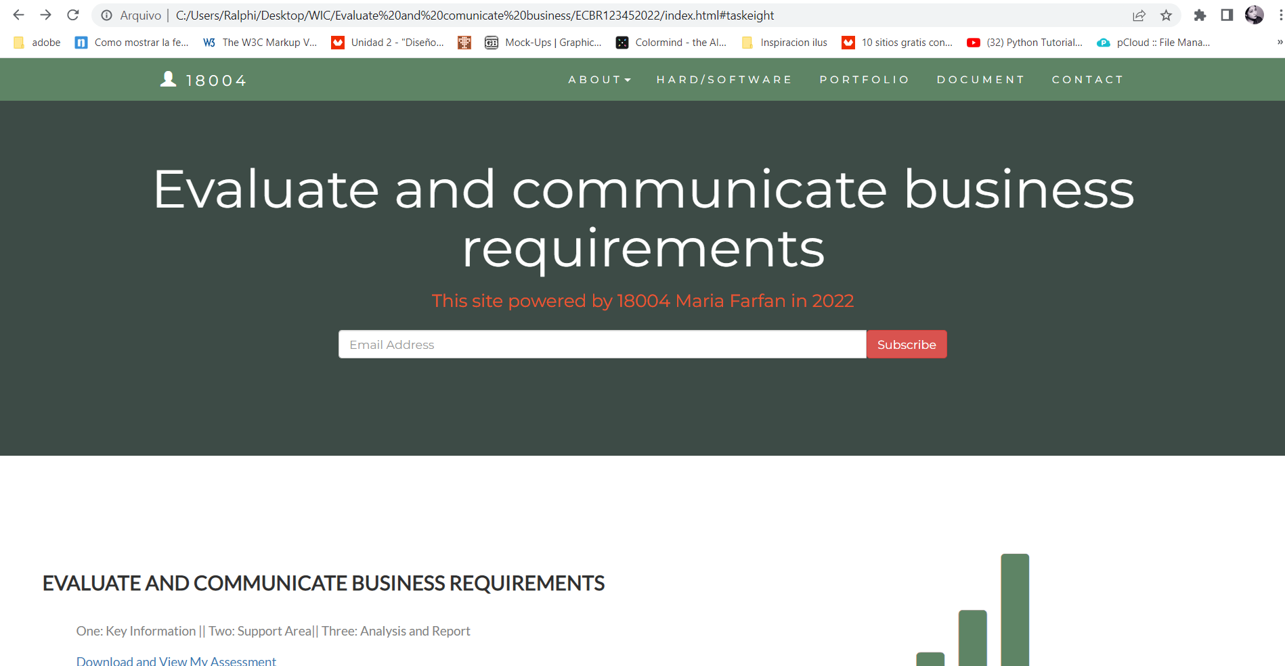

#### *Instructions:*

This assessment is to be completed individually. In this assessment you will be working through a number of written tasks based on case scenarios or research that relate directly to each element of competency for this cluster. Outlined below is information on how each of the tasks relates the element of competency covered.

Learn how to make Google Form: <https://www.youtube.com/watch?v=BtoOHhA3aPQ&t=4s>

Your tasks:

#### *Business Scenario*

D&K Books Pty Ltd is a bookstore owned by Mr. Dean Kerr. The business occupies two levels of an office building connected by escalators and lifts. D&K Books employs approximately six sales staff, one operation manager, two administrative officers, a bookkeeper and a marketing manager. They have an Ethernet network consisting of ten PCs (Intel I3 Desktop cloned), two switches, a router and three printers. They use the QuickBooks software to manage their entire business, including sales, inventory, ordering, accounts receivable, accounts payable, payroll and employee management. They also have two EFTPOS terminals one on each floor.

D&K Books has a Linux server that stores all of the data including the QuickBooks database. The server is backed up to tape regularly. They also have a website (hosted on an Australian ISP’s server, dynamic and static pages using asp.net) on which customers can browse the product catalogue and view current specials. They also lease a telephone system from Live Telecoms. The PABX (phone system) consists of a main switchboard and five remote phones with three incoming lines and a message-on-hold queue system.

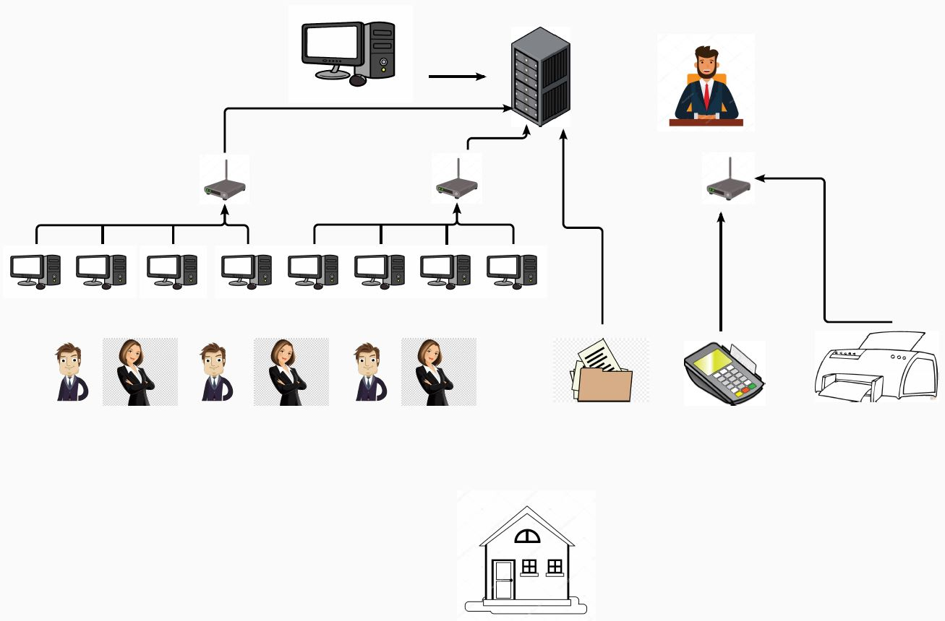

Good network system, you need setup at least:

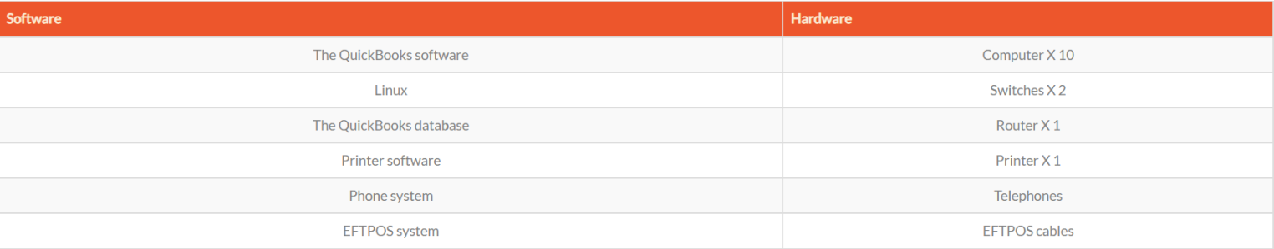

#### 

#### *Task 1: Determine support areas*

Identify information technology (HW and SW) and list the technology in use in D&K Books and consider the following:

* What sort of support does the technology require?
* Who is likely to provide this support?
* Does the support arrangement already exist?

Present your answer in a table such as the one below:

|  |  |  |  |  |
| --- | --- | --- | --- | --- |
| **Technology** | **Description** | **Support Required** | **Provider** | **Support Already exists? (Yes/No)** |
| QuickBooks Software | QuickBooks is an accounting software package developed and marketed by Intuit. | 64-bit Windows operating system  customisation, training, upgrades, bug fixes (patching), user support | <https://quickbooks.intuit.com/>   online to find more | No |
| PC’s | Intel Core i7  Intel® Core™ i7 processors have the most advanced chipsets and offer higher capacity than Core™ i5 CPUs. | At least 8 GB of RAM upgrades, repairs, troubleshooting, software for virus, install software for database | [https://www.centrecom.com.au](https://www.centrecom.com.au )  online to find more | No. Need find one person to do this job |
| Server  IconExperience » V-Collection » Server Icon | Linux Server  It is a variant of the Linux operating system that is designed to handle more intense storage and operational needs of larger organizations and their software. | Processor 64-bit Opteron, EM64T, RAM 1 GB or greater, RAM 1 GB or greater, Disk space 500 MB free space | <https://linuxhomeserver.com> | No |
| EFTPOS | Electronic funds transfer at point of sale is an electronic payment system involving electronic funds transfers based on the use of payment cards. | Power connection | <https://www.myzeller.com> | Yes |
| Telephone system | It is a telecommunications network that connects telephones, which allows telephone calls between two or more parties | Phone company | Telstra | Yes |
| Website | A website is a collection of web pages and related content that is identified by a common domain name and published on at least one web server. | Hosting | Godaddy | Yes |
| Network | A **network** consists of two or more computers that are linked in order to share resources (such as printers and CDs) | No external | No | No |

Please review my website: <https://maria191219.github.io/PM18004T42022/>

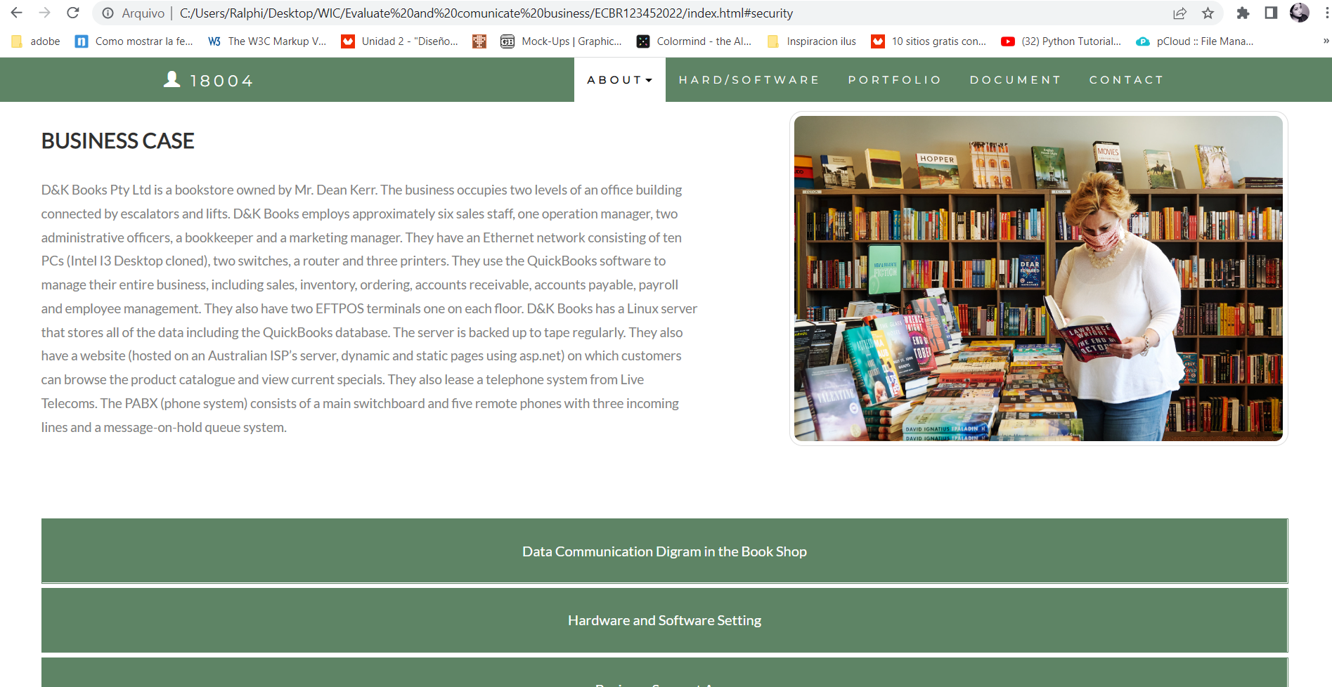

#### *Task 2: Identify stakeholders*

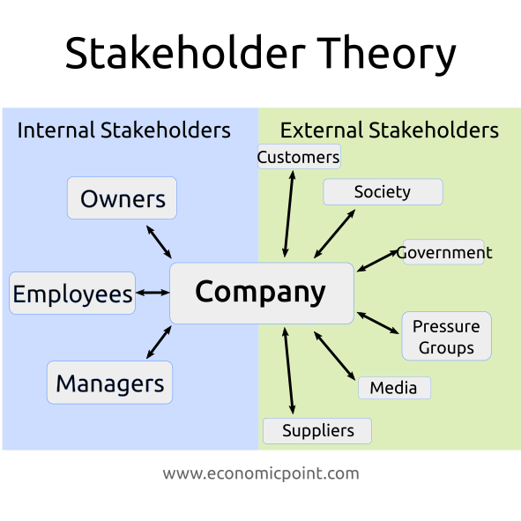 Identify stakeholders related in D&K Books system

The business owner, the relevant manager, the local workers and the remote workers, managers

It’s important to take into account the internal stakeholders, but also we need to take into account the external stakeholders like customers, media, suppliers, even the government.

#### *Task 3: Develop support procedures*

1. Describe one positive and one negative experience you have had when seeking assistance from a telecommunication company, an ISP or a computer supplier. Your experience may be via telephone, email or even voice recognition.

|  |  |  |
| --- | --- | --- |
| Type | Positive | Negative |
| Telephone | Easy to get answer | We cannot resolve the problem quick |
| Email | Document, Picture, words or any media | Take too long |
| Go to company | Face to face get answer | Cost time and money on trip |
| Chat from the web | Quick answer | Could be a robot |

1. Using the experiences described above please answer the following questions.
   1. What support aspects were professional and/or unprofessional?
   2. How long did the support process take?
   3. Were the steps logical?
   4. Did they solve your problem?
   5. Was the call deflected to another area?

|  |  |  |
| --- | --- | --- |
| Items | professional | unprofessional |
| What support aspects | Kind, gentle, Listening, worried | Be unfriendly, not being able to solve the customer's problem |
| How long | Very quick | Long time |
| Steps logical | Yes | No |
| Solve | Well | Can not |
| Another area | If has, will be solve very quick | If has, won’t be solve |

Using feedback form or Google survey form.

Here is the very simple survey demo:

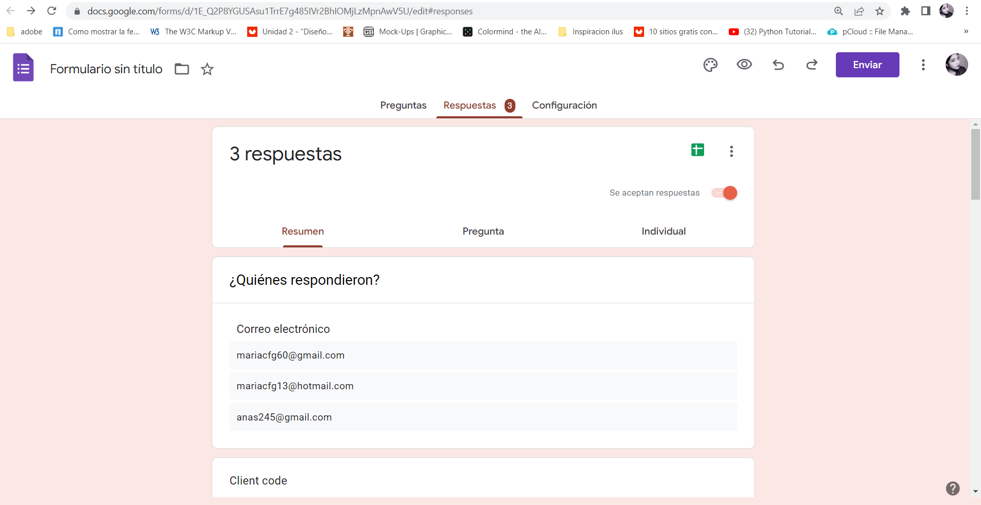

After I tested my friends, I could get nice response like:

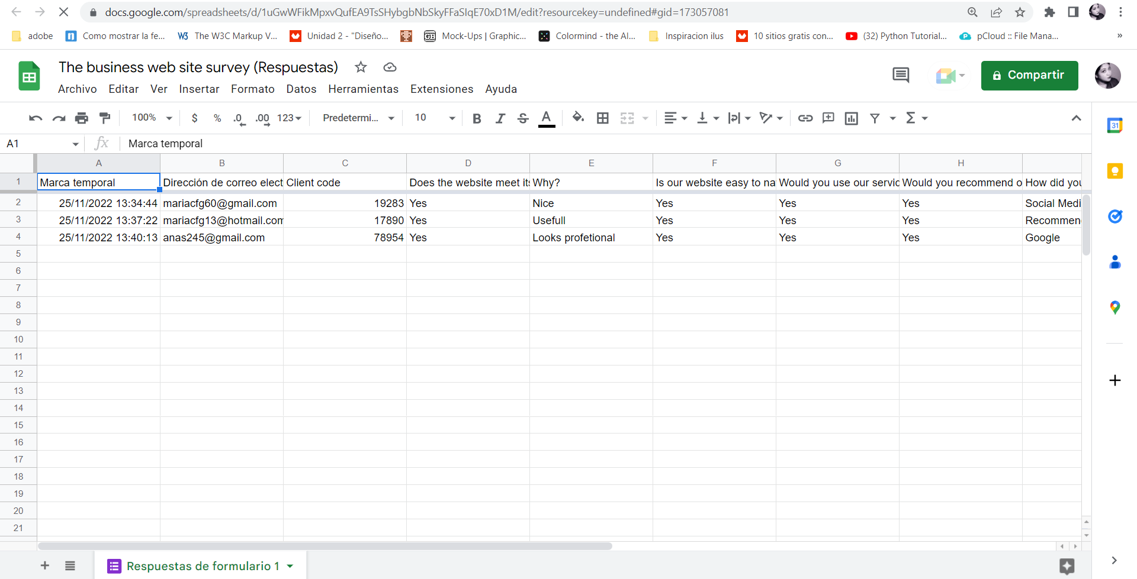

Or using link string:

<https://docs.google.com/spreadsheets/d/1uGwWFikMpxvQufEA9TsSHybgbNbSkyFFaSIqE70xD1M/edit?resourcekey=undefined#gid=173057081>

Please review my website: <https://maria191219.github.io/PM18004T42022/>

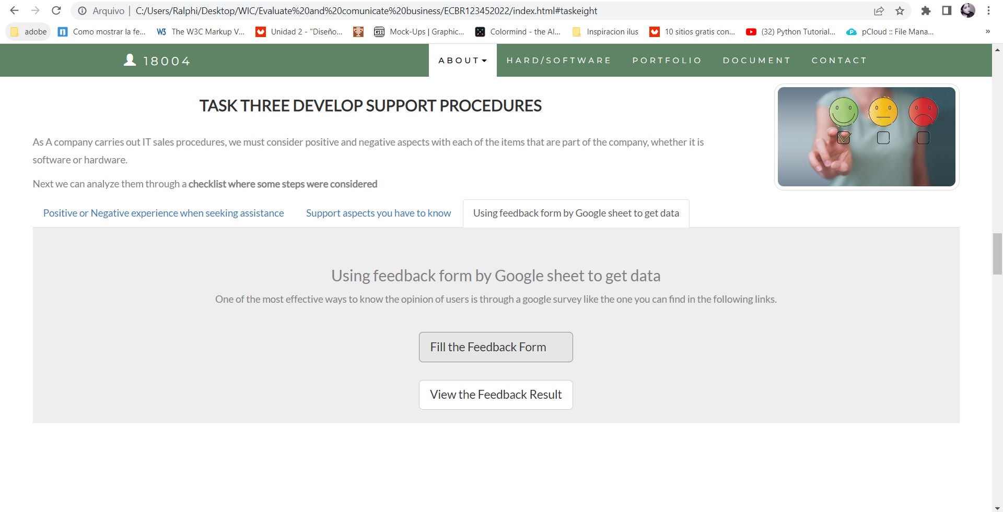

#### *Task 4: Assign Support Personnel*

Classify the following into soft skills and technical skills. Your answer should take the form of a table shown below.

|  |  |  |
| --- | --- | --- |
| **Skill** | **Soft skill** | **Technical skill** |
| A knowledge of Linux | X | X |
| The ability to work under pressure | X |  |
| The administration of Windows 2008 Server |  | X |
| The ability to formulate network and IT policies |  | X |
| The ability to write network documentation | X | X |
| The ability to give presentations | X |  |

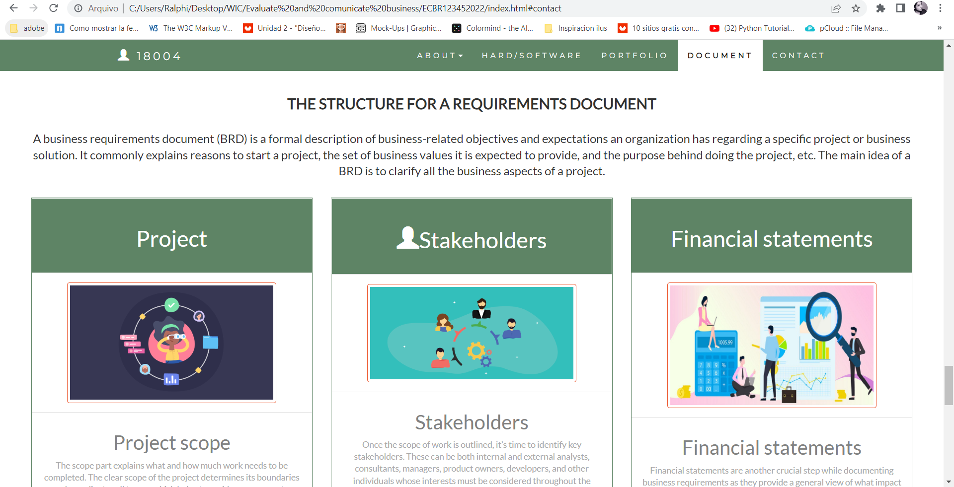

Here is about document re-equipment at support website: <https://maria191219.github.io/PM18004T42022/>

#### *Task 5: Short Answer Questions*

1. Explain the relationship between data, information and knowledge.

Data in their simplest form consist of raw alphanumeric values. Information is created when data are processed, organized, or structured to provide context and meaning. Information is essentially processed data. Knowledge is what we know.

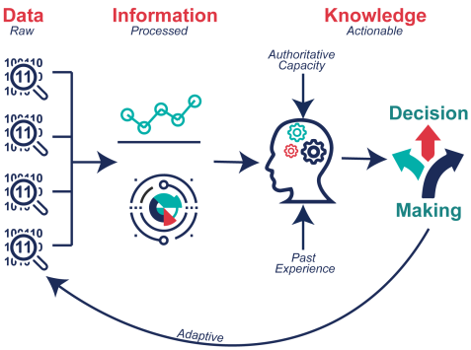

1. What is quantitative data and how can you use it.

Quantitative data are measures of values or counts and are expressed as numbers. Quantitative data are data about numeric variables (e.g. how many; how much; or how often). Qualitative data are measures of 'types' and may be represented by a name, symbol, or a number code.

Quantitative data is used when a researcher needs to quantify a problem, and answers questions like “what,” “how many,” and “how often.” This type of data is frequently used in math calculations, algorithms, or statistical analysis.

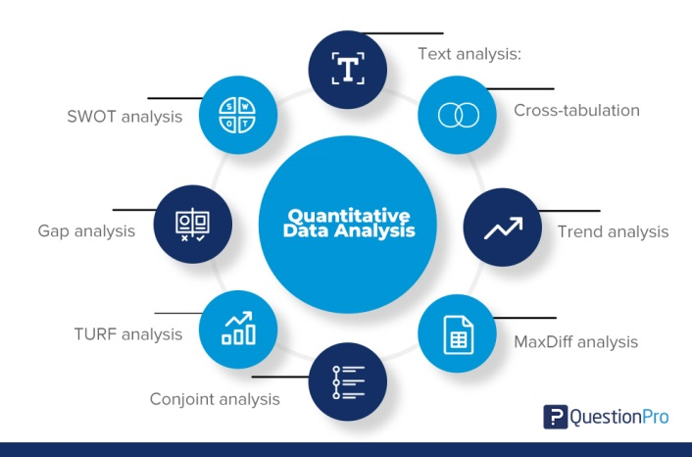

1. What is qualitative data and how can you use it.

What is Qualitative Data? Qualitative data is the descriptive and conceptual findings collected through questionnaires, interviews, or observation. Analysing qualitative data allows us to explore ideas and further explain quantitative results.

Qualitative data is used when you need to determine the particular trends of traits or characteristics or to form parameters for larger data sets to be observed. Qualitative data provides the means by which analysts can quantify the world around them.

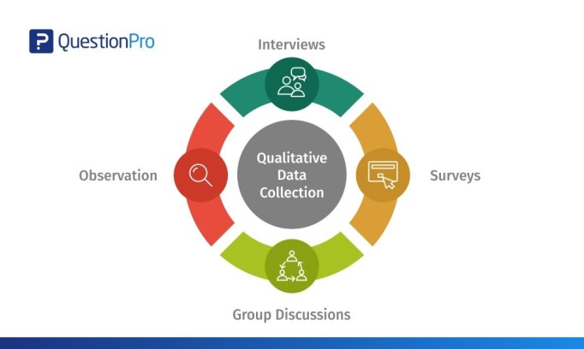

1. Give an example of how quantitative and qualitative data can be used in conjunction with each other

**Google Analytics + User Interviews**

Google Analytics offers a wealth of quantitative data, such as how many people visited your site, how they got there, and how long they stayed. The information is incredibly helpful and extremely detailed, but without thoughtful interpretation, it’s useless.

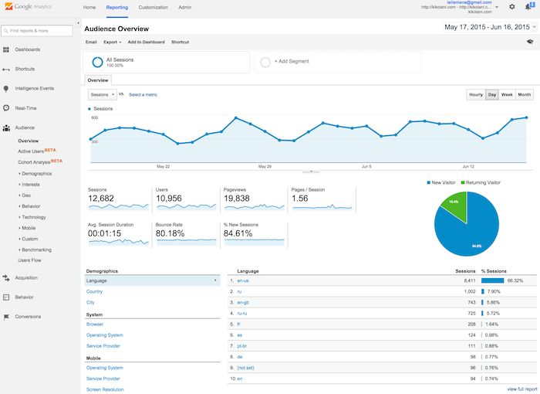

1. What sort of methods could you use to determine client requirements for a website design and key information sources?

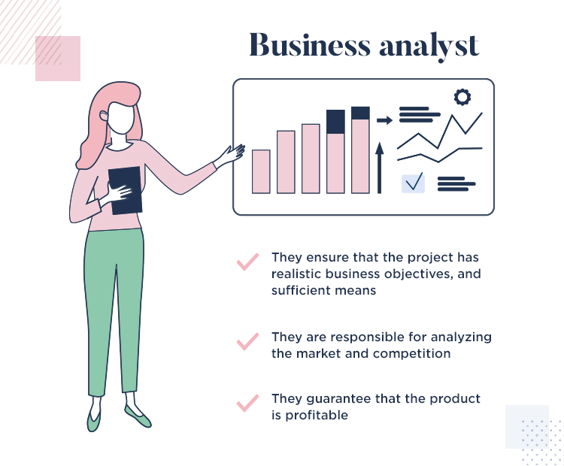

* Customer support
* Customer service centre
* Interviews.
* Questionnaires or Surveys.
* User Observation.
* Document Analysis.
* Interface analysis.

1. Give some examples of client requirements for a website design

* Functionality
* Performance
* Looks good
* Work uninterrupted
* Easy to update information

I made my web support page, could be accessed by: <https://wellsjohn220.github.io/ecbr>

#### *Task 6: Multiple Choice Questions*

1. 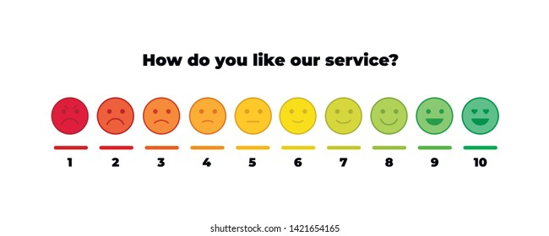Generally, how many points should a rating scale have?
   1. Five
   2. Four
   3. Ten
   4. Somewhere from 4 to 11 points

Web refers: <https://measuringu.com/scale-points/#:~:text=The%20psychometric%20literature%20suggests%20that,maintain%20too%20many%20response%20options>.

Reason: The psychometric literature suggests that having more scale points is better but there is a diminishing return after around 11 points

1. What is the problem(s) with this set of response categories to the question “What is your current age?”

* 1-5
* 5-10
* 10-20
* 20-30
* 30-40
  1. The categories are not mutually exclusive
  2. The categories are not exhaustive
  3. Both a and b are problems
  4. There is no problem with the above set of response categories

Web refers: <https://english.stackexchange.com/questions/446824/from-the-age-or-ages-of-fifteen-to-twenty-one>

Reason: A range of ages ("from age 1 to age 2") starts at one age (singular) and ends at another. We can also talk about the period between a pair of ages (plural). The expression "from the age of fifteen to the age of twenty-one" can be written without the second occurrence of "from the age of", as in your example.

1. You should mix methods in a way that provides complementary strengths and no overlapping weaknesses. This is known as the fundamental principle of mixed research.

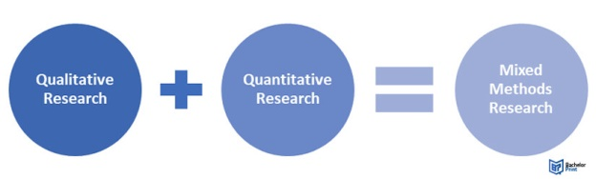

* 1. True
  2. False

Reason: According to the fundamental principle of mixed research, the researcher should use a mixture or combination of methods that has complementary strengths and no overlapping weaknesses. This principle is important because it provides the researcher with a logic for mixing quantitative and qualitative research approaches.

Web refers:

[https://edge.sagepub.com](https://edge.sagepub.com )

1. According to the text, questionnaires can address events and characteristics taking place when?
   1. 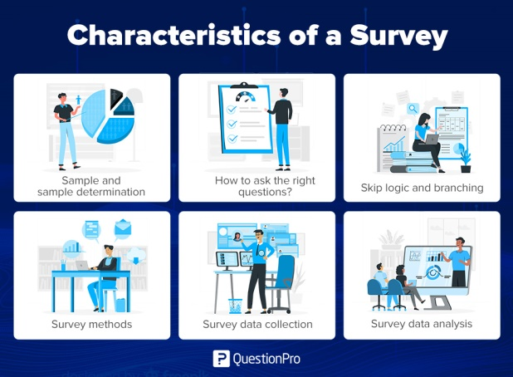In the past (retrospective questions)
   2. In the present (current time questions)
   3. In the future (prospective questions)
   4. All of the above

Reason: Questionnaires are popular research methods because they offer a fast, efficient and inexpensive means of gathering large amounts of information from sizeable sample volumes. These tools are particularly effective for measuring subject behaviour, preferences, intentions, attitudes and opinions.

Web refers: <https://www.cint.com/blog/what-is-a-questionnaire-and-how-is-it-used-in-research>

1. 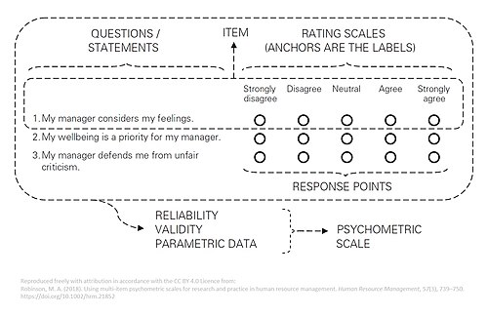Which of the following are principles of questionnaire construction?
   1. Consider using multiple methods when measuring abstract constructs
   2. Use multiple items to measure abstract constructs
   3. Avoid double-barrelled questions
   4. All of the above
   5. Only b and c

Reason: There are at least nine distinct steps: decide on the information required; define the target respondents, select the method(s) of reaching the respondents; determine question content; word the questions; sequence the questions; check questionnaire length; pre-test the questionnaire and develop the final questionnaire.

Web refers: <https://www.fao.org/3/w3241e/w3241e05.htm>

1. Which of these is not a method of data collection?
   1. 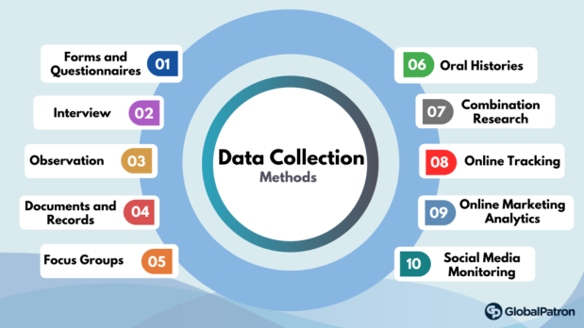Questionnaires
   2. Interviews
   3. Experiments
   4. Observations

Reason: The most common data collection methods that you can utilize are:

* Experiment
* Survey
* Observation
* Ethnography
* Secondary data collection
* Archival research
* Interview/focus group

Web refers: <https://www.iteratorshq.com/blog/data-collection-best-methods-practical-examples/>

1. Secondary/existing data may include which of the following?
   1. Official documents
   2. Personal documents
   3. 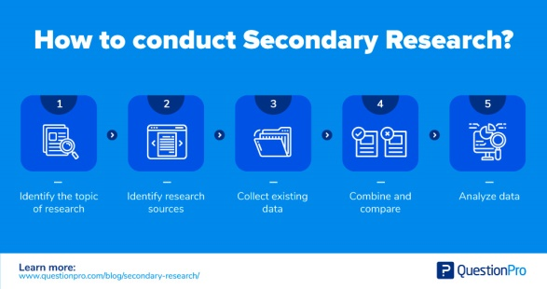Archived research data
   4. All of the above

Reason: Secondary data means data collected by someone else earlier. Surveys, observations, experiments, questionnaire, personal interview, etc. Government publications, websites, books, journal articles, internal records etc

Web refers: <https://researchguides.ben.edu/c.php?g=282050&p=4036581#:~:text=Secondary%20data%20means%20data%20collected%20by%20someone%20else%20earlier.&text=Surveys%2C%20observations%2C%20experiments%2C%20questionnaire,journal%20articles%2C%20internal%20records%20etc>.

1. An item that directs participants to different follow-up questions depending on their response is called a ____________.
   1. 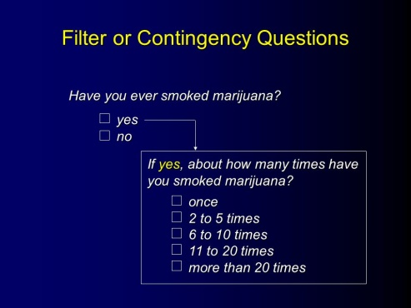Response set
   2. Probe
   3. Semantic differential
   4. Contingency question

Reason: Contingency questions are questions that are only to be answered by some subgroup(s) of respondents. For example, "If you own your home, how long have you owned it?" Contingency questions may have either closed-ended or open-ended response options.

Web refers: <https://home.csulb.edu/~msaintg/ppa696/696qstin.htm#:~:text=Contingency%20questions%20are%20questions%20that,or%20open%2Dended%20response%20options>.

1. 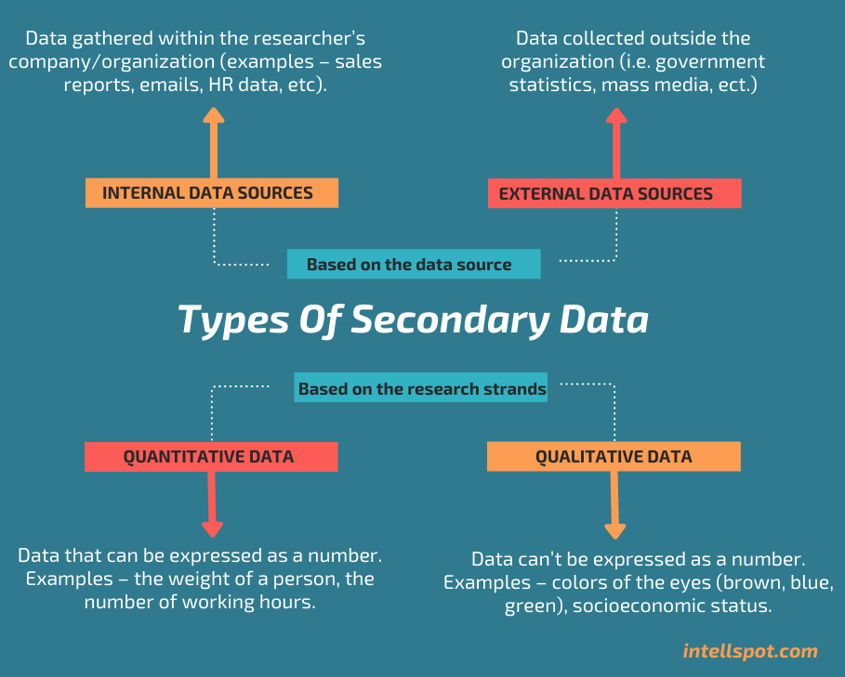Which of the following terms best describes data that were originally collected at an earlier time by a different person for a different purpose?
   1. Primary data
   2. Secondary data
   3. Experimental data
   4. Field notes

Reason: Secondary data is research data that has previously been gathered and can be accessed by researchers. The term contrasts with primary data, which is data collected directly from its source.

Web refers: <https://www.techtarget.com/whatis/definition/secondary-data>

1. 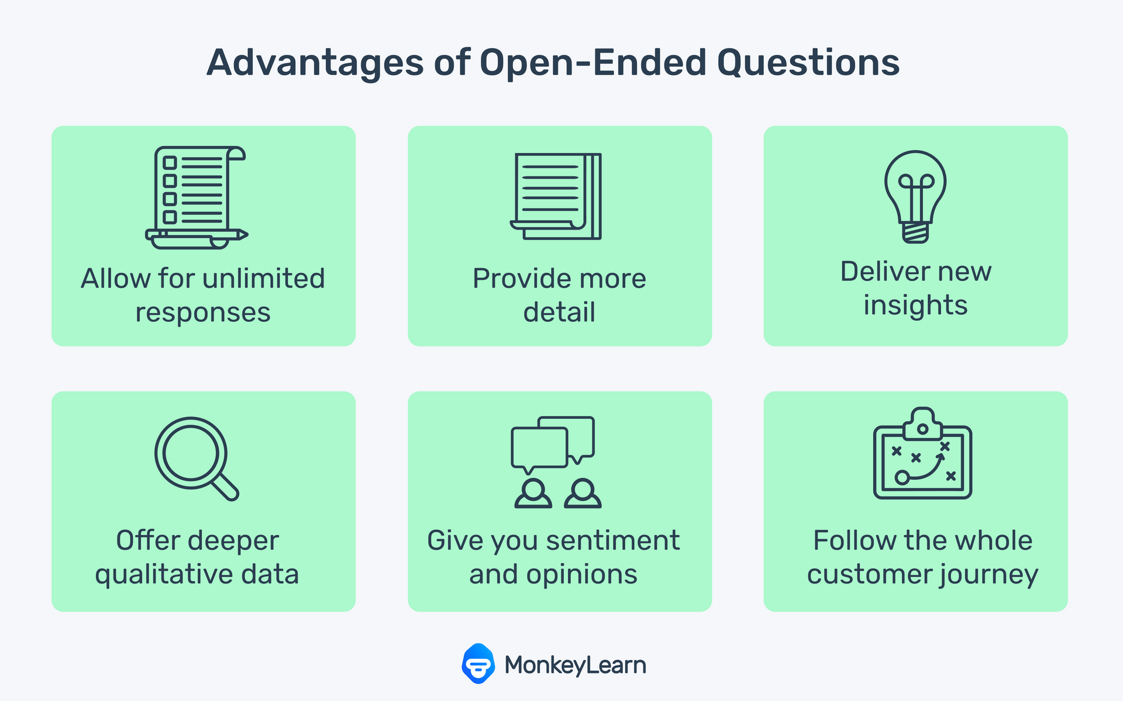Researchers use both open-ended and closed-ended questions to collect data. Which of the following statements is true?
   1. Open-ended questions directly provide quantitative data based on the researcher’s predetermined response categories
   2. Closed-ended questions provide quantitative data in the participant’s own words
   3. Open-ended questions provide qualitative data in the participant’s own words
   4. Closed-ended questions directly provide qualitative data in the participants’ own words

Reason: Open-ended questions are questions that do not provide participants with a predetermined set of answer choices, instead allowing the participants to provide responses in their own words. Open-ended questions are often used in qualitative research methods and exploratory studies.

Web refers: <https://methods.sagepub.com/reference/the-sage-encyclopedia-of-communication-research-methods/i14345.xml#:~:text=Open-ended%20questions%20are%20questions,research%20methods%20and%20exploratory%20studies>.

1. Open-ended questions provide primarily ______ data.
   1. 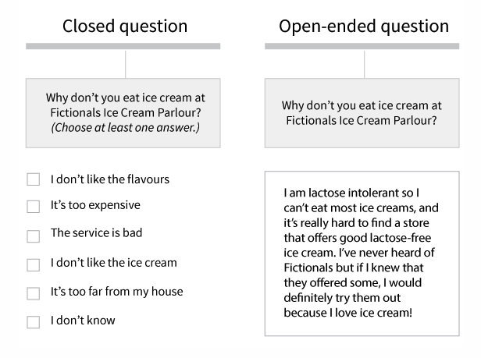Confirmatory data
   2. Qualitative data
   3. Predictive data
   4. None of the above

Reason: A question in a survey for which there are no multiple options to choose from, with the respondent having to answer in their own words. Open-ended questions provide primarily qualitative data, and are generally used in exploratory research.

Web refers:

<https://www.pmlive.com/intelligence/healthcare_glossary/Terms/o/open_ended_question#:~:text=A%20question%20in%20a%20survey,gernerally%20used%20in%20exploratory%20research>.

1. Which of the following is true concerning observation?
   1. It takes less time than self-report approaches
   2. 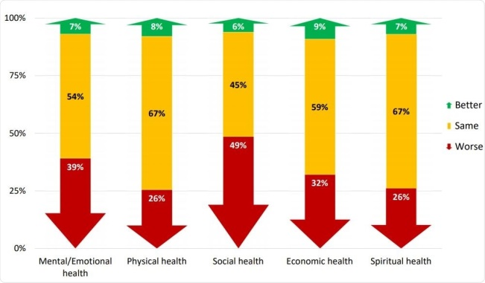It costs less money than self-report approaches
   3. It is often not possible to determine exactly why the people behave as they do
   4. All of the above

Reason: Questionnaires are popular research methods because they offer a fast, efficient and inexpensive means of gathering large amounts of information from sizeable sample volumes. These tools are particularly effective for measuring subject behavior, preferences, intentions, attitudes and opinions.

Web refers: <https://www.cint.com/blog/what-is-a-questionnaire-and-how-is-it-used-in-research>

1. 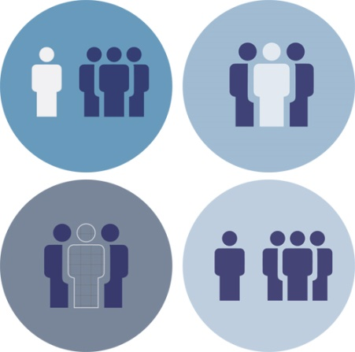Qualitative observation is usually done for exploratory purposes; it is also called ___________ observation.
   1. Structured
   2. Naturalistic
   3. Complete
   4. Probed

Reason: Naturalistic observation is a qualitative research method where you record the behaviors of your research subjects in real world settings. You avoid interfering with or influencing any variables in a naturalistic observation. You can think of naturalistic observation as “people watching” with a purpose.

Web refers: <https://www.scribbr.com/methodology/naturalistic-observation/#:~:text=Naturalistic%20observation%20is%20a%20qualitative,people%20watching%E2%80%9D%20with%20a%20purpose>.

1. When constructing a questionnaire, it is important to do each of the following except ______.
   1. Use "leading" or "loaded" questions
   2. 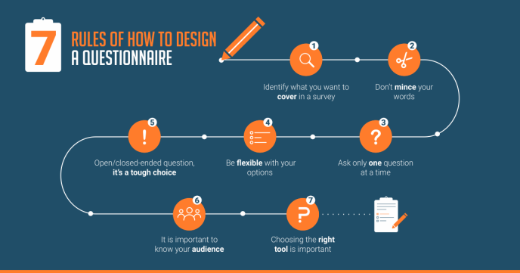Use natural language
   3. Understand your research participants
   4. Pilot your test questionnaire

Reason: A good questionnaire should be valid, reliable, clear, succinct and interesting. It is important to design the questionnaire based on a conceptual framework, scrutinise each question for relevance and clarity, and think of the analysis you are going to perform at the end of the day.

Web refers: <https://www.ncbi.nlm.nih.gov/pmc/articles/PMC4797036/#:~:text=A%20good%20questionnaire%20should%20be%20valid%2C%20reliable%2C%20clear%2C%20succinct,the%20end%20of%20the%20day>.

1. Another name for a Likert Scale is a(n):
   1. 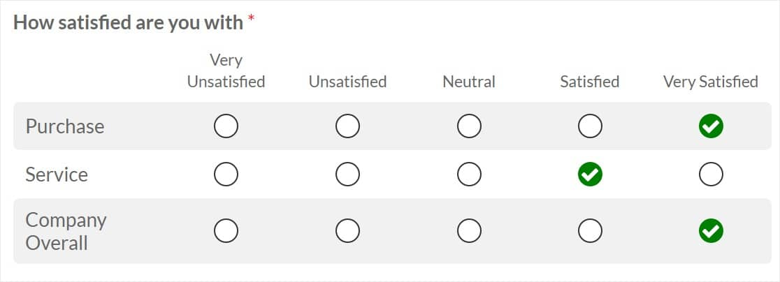Interview protocol
   2. Event sampling
   3. Summated rating scale
   4. Ranking

Reason: Likert scales are often called summative scales. Whether individual Likert items can be considered as interval-level data, or whether they should be treated as ordered-categorical data is the subject of considerable disagreement in the literature,with strong convictions on what are the most applicable methods. This disagreement can be traced back, in many respects, to the extent to which Likert items are interpreted as being ordinal data.

Web refers: <https://en.wikipedia.org/wiki/Likert_scale#:~:text=Hence%2C%20Likert%20scales%20are%20often%20called%20summative%20scales>.

1. Which of the following is not one of the six major methods of data collection that are used by educational researchers?
   1. 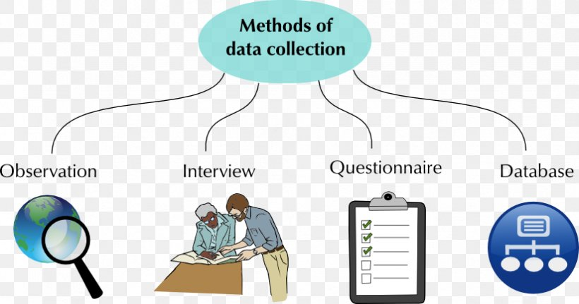Observation
   2. Interviews
   3. Questionnaires
   4. Checklists

Reason: The most commonly used methods are: published literature sources, surveys (email and mail), interviews (telephone, face-to-face or focus group), observations, documents and records, and experiments.

Web refers: <https://callygood.medium.com/6-methods-of-data-collection-e946e993b930#:~:text=The%20most%20commonly%20used%20methods,documents%20and%20records%2C%20and%20experiments>

1. 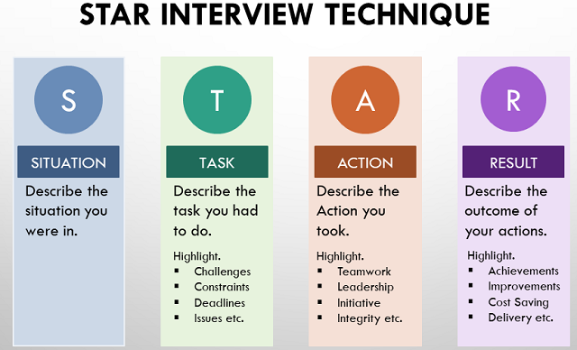The type of interview in which the specific topics are decided in advance but the sequence and wording can be modified during the interview is called:
   1. The interview guide approach
   2. The informal conversational interview
   3. A closed quantitative interview
   4. The standardized open-ended interview

Reason: General interview guide approach - the guide approach is intended to ensure that the same general areas of information are collected from each interviewee; this provides more focus than the conversational approach, but still allows a degree of freedom and adaptability in getting the information from the interviewee.

Web refers: <https://www.public.asu.edu/~kroel/www500/Interview%20Fri.pdf>

1. Which one of the following in not a major method of data collection:
   1. 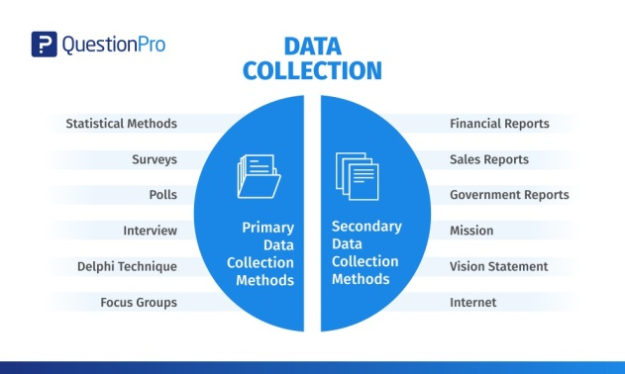Questionnaires
   2. Interviews
   3. Secondary data
   4. Focus groups
   5. All of the above are methods of data collection

Reason: Some of the primary data-collection methods covered below are quantitative, dealing with countable data. Others are qualitative, meaning that they consider factors other than numerical values. Generally, questionnaires, surveys, documents, and records are quantitative, while interviews, focus groups, observations, and oral histories are qualitative. There can also be crossover between the two methods.

Web refers: <https://www.jotform.com/data-collection-methods/>

1. 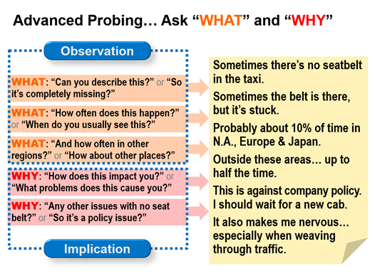A question during an interview such as “Why do you feel that way?” is known as a:
   1. Probe
   2. Filter question
   3. Response
   4. Pilot

Reason: Probing is asking follow-up questions when we do not fully understand a response, when answers are vague or ambiguous or when we want to obtain more specific or in-depth information. For example: “What did you like best about the program?”

Web refers: <https://fyi.extension.wisc.edu/programdevelopment/files/2016/04/Tipsheet34.pdf>

1. A census taker often collects data through which of the following?
   1. 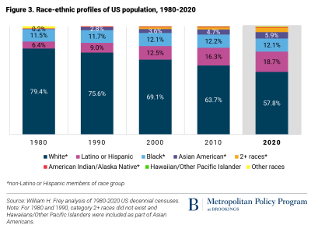Standardized tests
   2. Interviews
   3. Secondary data
   4. Observations

Reason: A census taker or census enumerator is someone hired from your local community by the Census Bureau to knock on doors and collect responses to the census for households that have not yet responded.

Web refers: <https://censuscounts.org/wp-content/uploads/2019/12/FACTSHEET-HowtoIdentifyaCensusTaker.pdf>

1. The researcher has secretly placed him or herself (as a member) in the group that is being studied. This researcher may be which of the following?
   1. A complete participant
   2. An observer-as-participant
   3. A participant-as-observer
   4. None of the above

Reason: A research subject is an individual that participates in research. Information (or 'data') is collected from or about the individual to help answer the question under study. Sometimes research subjects are referred to as human subjects, research participants or study volunteers.

Web refers: <https://www.rochester.edu/ohsp/subject/participatingInResearch.html>

1. Which of the following is not a major method of data collection?
   1. 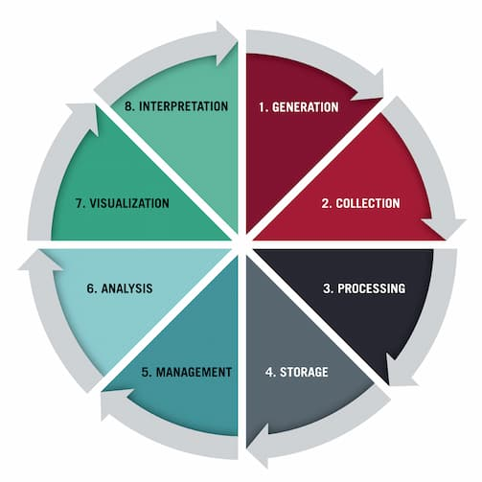Questionnaires
   2. Focus groups
   3. Correlational method
   4. Secondary data

Reason: The most common data collection methods that you can utilize: Experiment, survey, observation, ethnography, secondary data collection, archival research, Interview/focus group.

Web refers: <https://www.iteratorshq.com/blog/data-collection-best-methods-practical-examples/>

1. Which type of interview allows the questions to emerge from the immediate context or course of things?
   1. 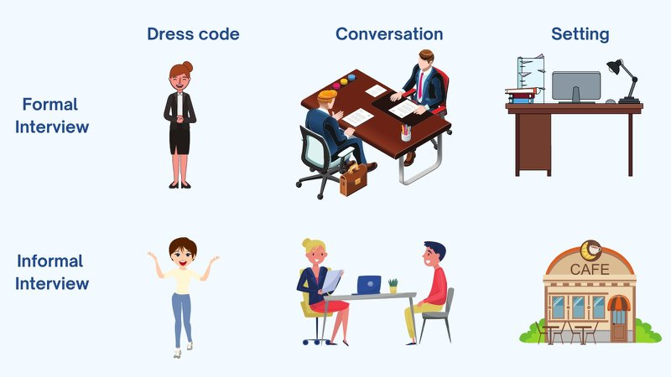Interview guide approach
   2. Informal conversational interview
   3. Closed quantitative interview
   4. Standardized open-ended interview

Reason: An informal interview, also known as a conversational or informal chat interview, is a non-formal job interview, often held in a neutral setting such as a café, usually over food or drink. Informal interviews can also be virtual.

Web refers: <https://targetjobs.co.uk/careers-advice/interviews-and-assessment-centres/what-informal-interview-and-how-can-you-succeed-one>

1. 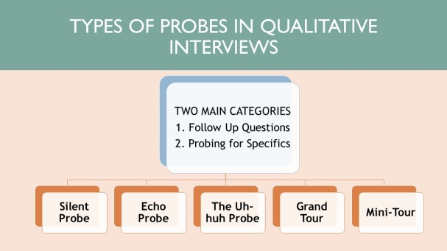When conducting an interview, asking "Anything else?, What do you mean?, Why do you feel that way?," etc, are all forms of:
   1. Contingency questions
   2. Probes
   3. Protocols
   4. Response categories

Reason: Probes for specifics are used when the respondent doesn't bring up some of the topics that you as the interviewer is most interested in.

Web refers: <https://www.linkedin.com/pulse/main-types-probes-qualitative-interviews-/>

1. When constructing a questionnaire, there are 15 principles to which you should adhere. Which of the following is not one of those principles?
   1. 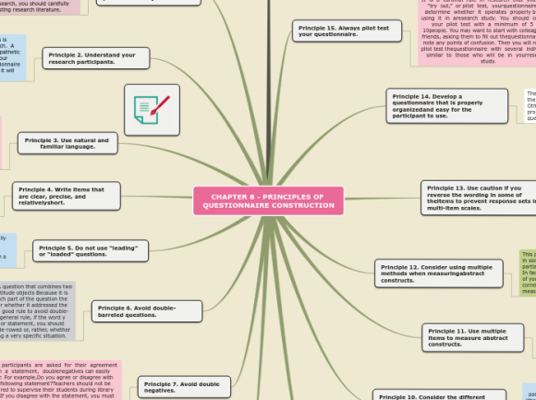Do not use "leading" or "loaded" questions
   2. Avoid double-barrelled questions
   3. Avoid double negatives
   4. Avoid using multiple items to measure a single construct

Reason: Principles of Questionnaire Construction:

1 Make sure the questionnaire items match your research objectives.

2 Understand your research participants.

3 Use natural and familiar language.

4 Write items that are clear, precise, and relatively short.

5 Do not use “leading”or “loaded”questions.

6 Avoid double-barreled questions.

7 Avoid double negatives.

8 Determine whether an open-ended or a closed-ended question is needed.

9 Use mutually exclusive and exhaustive response categories for closed-ended questions.

10 Consider the different types of response categories available for closed-ended questionnaire items.

11 Use multiple items to measure abstract constructs.

12 Consider using multiple methods when measuring abstract constructs.

13 Use caution if you reverse the wording in some of the items to prevent response sets in multi-item scales. 14 Develop a questionnaire that is easy for the participant to use.

15 Always pilot test your questionnaire.

Web refers: <https://www.sagepub.com/sites/default/files/upm-binaries/26101_7.pdf>

1. A customer-based Service Level Agreement structure includes:
   1. 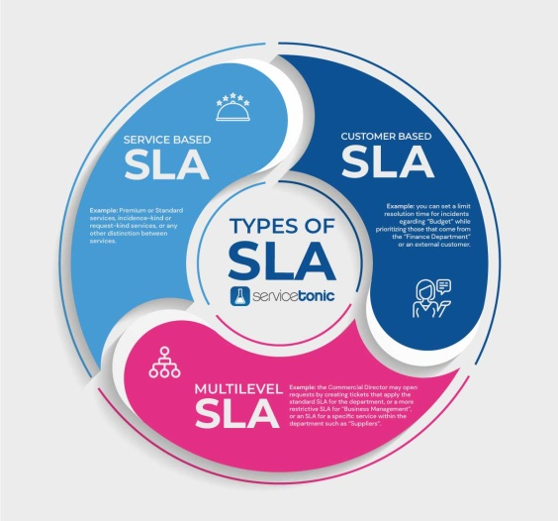An SLA covering all Customer groups and all the services they use
   2. SLAs for each service that are Customer-focused and written in business language
   3. An SLA for each service type, covering all those Customer groups that use that Service
   4. An SLA with each individual Customer group, covering all of the services they use

Reason: The main elements of a good SLA are:

* Overall objectives. The SLA should set out the overall objectives for the services to be provided.
* Description of the Services. The SLA should include a detailed description of the services.
* Performance Standards.
* Compensation/Service Credits.
* Critical Failure.

Web refers: <https://www.keystonelaw.com/keynotes/service-level-agreements>

1. Which of the following best describes the goal of Service Level Management?
   1. 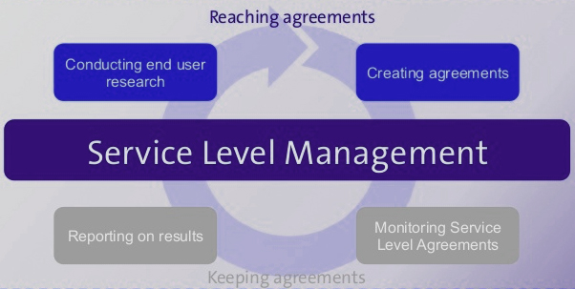To maintain and improve IT service quality in line with business requirements
   2. To provide IT services at the lowest possible cost by agreeing with Customers their minimum requirements for service availability and ensuring performance does not exceed these targets
   3. To provide the highest possible level of service to Customers and continuously improve on this through ensuring all services operate at maximum availability
   4. To ensure that IT delivers the same standard of service at the least cost

Reason: The purpose of Service Level Management is to ensure that all current and planned IT services are delivered to agreed achievable targets.

Web refers: <https://www.alaska.edu/files/oit/PinkSCAN_slm.pdf>

1. The process to implement SLAs comprises of the following activities in sequence:
   1. 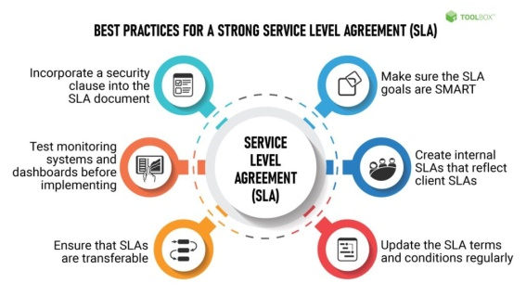Draft SLAs, catalogue services, review underpinning contracts and OLAs, draft SLRs, negotiate, agree SLAs
   2. Draft SLAs, review underpinning contracts and OLAs, negotiate, catalogue services,
   3. Review underpinning contracts and OLAs, draft SLAs, catalogue services, negotiate, agree SLAs
   4. Catalogue services, establish SLRs, review underpinning contracts and OLAs, negotiate service levels, agree SLAs

Reason: Stereolithography (SLA) is an industrial 3D printing process used to create concept models, cosmetic prototypes, and complex parts with intricate geometries in as fast as 1 day. A wide selection of materials, extremely high feature resolutions, and quality surface finishes are possible with SLA.

1. Which of the following is an example of a service level agreement (SLA) between information systems support unit and a research unit in the laboratories of a large company?
   1. The maximum response time to get the system operational should it fail.
   2. The minimum ‘up-time’.
   3. The types of information that will be provided as standard.
   4. All of the above

Reason: "A strategy for improving business performance through the commitment and involvement of all employees to fully satisfying agreed customer requirements, at the optimum overall costs, through the continuous improvement of the products and services, business processes and people involved."

Web refers: <https://www.managers-net.com/total_quality_management.html>

1. Some organisations bring a degree of formality to the internal customer concept by encouraging (or requiring) different parts of the operation to agree on:
   1. 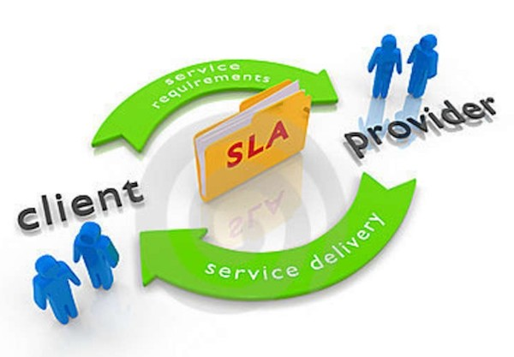Internal service agreements
   2. Service level agreements
   3. Formal provision agreements
   4. Delivery agreements

Reason: A service-level agreement is a commitment between a service provider and a customer. Particular aspects of the service – quality, availability, responsibilities – are agreed between the service provider and the service user.

Web refers: <https://en.wikipedia.org/wiki/Service-level_agreement>

## Index

B

bookstore 3

C

categories 11

closed-ended 12

D

data collection 14

L

Linux server 3

N

negative experience 6

network 3

O

open-ended 12

S

Service Level 14

service level agreement 15

service quality 14

soft skills 9

support 6

T

technology 4

telecommunications 6